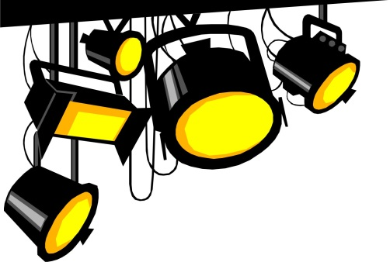
THEATRE DESIGN/TECH
Mr. Ryan Erwin
ryan.erwin@jordandistrict.org

Course Overview
Students will learn the basics of design and tech theatre through assignments and projects. They will also be introduced to the fundamentals of the many different aspects of theatre, such as; costuming, set, props, lights, sound and stage management.
Course Objectives
The following is an overview of the Jordan School District standards for Stage Design/Tech.
- Create
- Perform
- Respond
- Connect
Citizenship
To earn high citizenship marks, students must exhibit the TIGER traits in our class. We will go over how to actively live the TIGER traits in class.
OTHER IMPORTANT STUFF
- Let’s keep the classroom and the auditorium clean.
- I teach middle school by choice, so please feel free to come and talk to me if you have a problem please come talk to me. I care about you.
- Please dispose of your gum when you walk in.
- Come ready to have fun.
Assignments Breakdown Theatre Design/Tech
Play Reports 10%
There will be two play reports due this semester. We will be seeing ‘Midsummer Night’s Dream’ in February at Riverton High.
Projects 70%
There are a variety of projects in this class from monologues, scenes and group work. Rubrics will be available for each project. If you don’t like your grade on any project you can take the feedback and retake the project for a better grade.
Rehearsal & Performance 20%
All students will have a responsibility backstage for Acting class play in May, which in involves after school time during the week of May 14-17. If you are unable to work on the show, speak to Mr. Erwin ASAP to get something figured out.

